

ATX Outwear

Marketing Analytics (MIS 382N)



September 27, 2016

Davis Townsend

Professor Sonnier

1. **Overall Average Buy Rate: 2.38%**

-found by dividing the number of customers who bought by total customers (228/9337)

**For the top quintile of Recency the average rate is higher than the average buy rate, while the rate is lower for the bottom quintile as seen below**. These percentages were found by creating a pivot table with rows as the recency quintile column and the values as the average of the buy rates.

|  |  |
| --- | --- |
| **Row Labels** | **Average of buy** |
| 1 | 3.79% |
| 2 | 3.17% |
| 3 | 1.72% |
| 4 | 1.48% |
| 5 | 1.78% |
| **Grand Total** | **0.023836905** |

1. **They can expect around 2072 customer to buy**. I got this number by finding the number of customers in the rollout segment and multiplying each segment by their cell response rate calculated from the in sample response of each segment. This way I got the expected number of buyers for each RFM segment and then simply added all these up to get the total expected number of buyers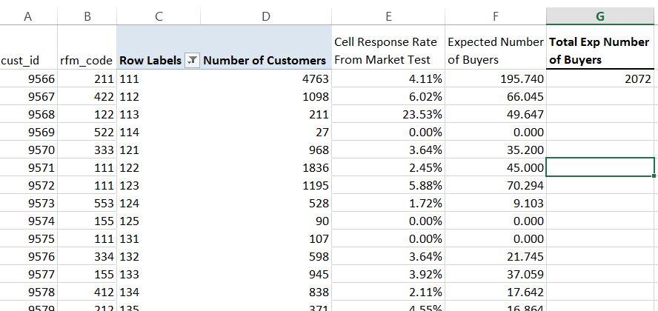

3)

Break-even Response rate: (Total Mailing Cost) / (Profit per unit) = # Required Responses

🡪# Required Responses / Number People Sending Offer to = Required Response rate

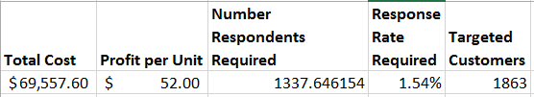

This being said I used Excel to calculate that I needed a 1.54% response rate to break even.

After this I just went to my rollout data and found the cumulative number of buyers up to the point in which the next cell response rate was lower than the breakeven response rate required as seen below.

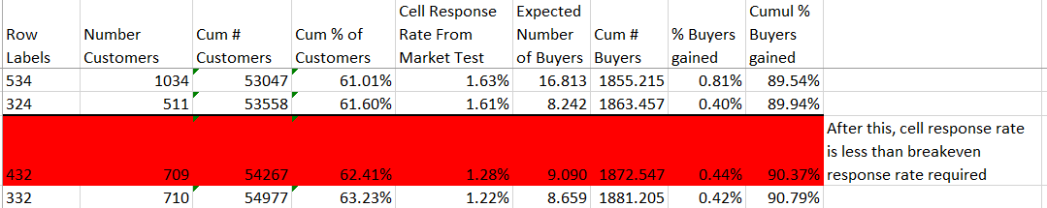

4)

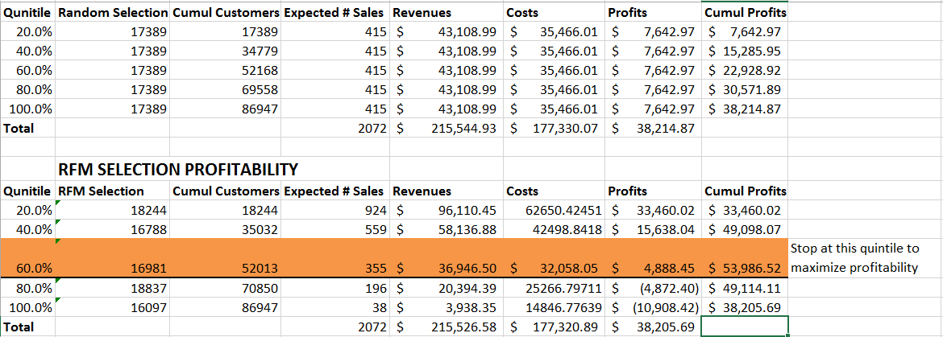

So I calculated profitability for Random Selection of mailings to customers and then with RFM selection and have shown where to maximize profits for the RFM selection approach.

For random selection I just took an equal number of customers for each quintile and calculated expected sales with the average buy rate (2.38%). Then I found revenues by multiplying $104 (the amount gained from each purchase) by the number of expected sales, subtracted the costs (($0.8 * number of customers) + ($52 * Expected Sales)) to get Profits, and lastly calculated cumulative profits for each quintile. We see a slow linear increase in cumulative profits from this approach.

For the RFM Selection most of the calculations are the same except that for the number of customers who were selected I used the number of customers who comprised the specified quintile (cumulative % of customers in the spreadsheet) which were in the rollout tab sorted by cell response rates from the market test. Then I summed up the expected number of buyers along these cells to get the expected # sales, and the rest of the calculations are the same as before.

Below I created a Final Analysis rundown of the profitability and ROI of mailing to everyone vs mailing based on targeted RFM Selection:

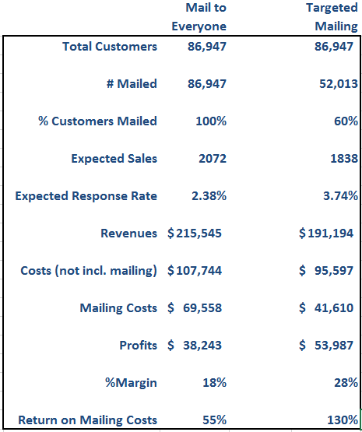

Just a little explanation on where these numbers came from in the final analysis: # Mailed came from the number of customers in the 3rd quintile which is also the % of customers mailed, 60%. Expected Sales came from the average rate for mail to everyone and from the expected # buyers based on the cell response rate from the market data for the targeted mailing. Expected response rate is just the average for everyone and for targeted I took the average of all the cell response rates from the market data up to the 60% customer point. Revenues are just $104 * the expected sales. Costs are just $52 * the expected sales (since the store only keeps half the revenue, the other half are assumedly costs). Mailing costs are just $0.8 * the number of customers mailed. Profits is just Revenues – (Costs not including mailing + mailing costs). % Margin is Profits / Revenues. Return on Mailing Costs is Profits / Mailing Costs.

Finally I simply created a graph showing the relationships between RFM and Random Selection and differences in Cumulative Profitability

The reason the targeted approach is more profitable is because you are mailing to the groups of people, as classified by the RFM analysis, who are more likely to respond to the mailing and buy the product. In our spreadsheet we see that for most of the groups we are targeted the customers have a higher cell response rate from the market test data than the average bought rate of 2.38%. This means that we are overall going to do much better since we are targeting the customers with an above average propensity to buy our product based on the mailings and not wasting money on the customers who aren’t as likely to buy the product.

The downfalls of this RFM approach is the fact that you may still want to mail to these low propensity to buy customers to generate awareness of your product, or you may not want to mail to some of the high propensity to buy customers as to not inundate them with mail and annoy them. These types of things are much harder to analyze and would require domain knowledge and intuition to further decide what the best approach to these mailings would be based on how our customers react to receiving mail.